**Work Order Details in Sales Order**

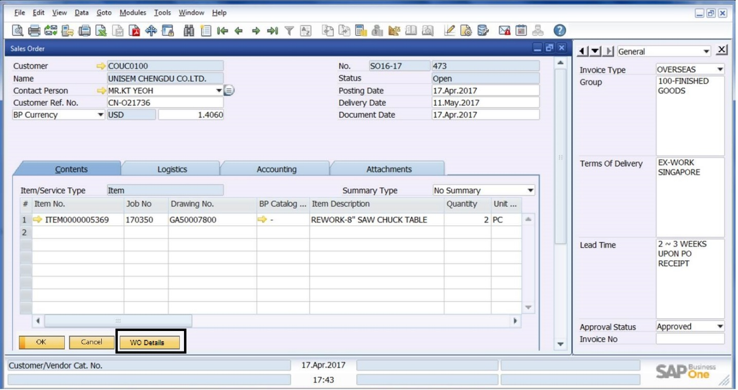

A new button called **‘WO Details’** (Work Order Details) will be added to the Sales Order Screen as highlighted in the above screenshot.

When you click on **WO Details** a pop-up window will open as shown below.

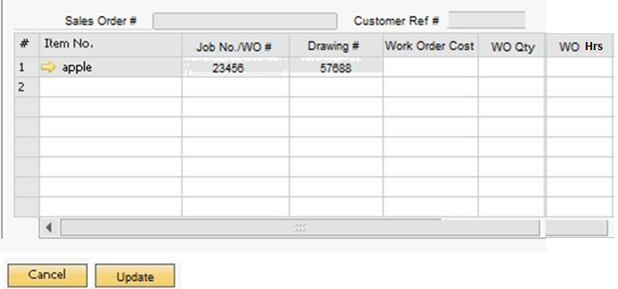

In the above screen the user can fill in the following details:

* **Customer Ref #** - This will come from Sales Order and will be non-editable
* **Sales Order #-** This will come from Sales Order and will be non-editable
* **Job No./Work Order #** - This will come from Sales Order and will be non-editable
* **Drawing #** - This will come from Sales Order and will be non-editable
* ***Work Order Cost*** *– Enter work order cost details*
* ***WO Quantity*** *– Enter work order quantity details*
* ***WO Hours*** *– Enter work order hours details*
* **Item #** - This field will be greyed out. User cannot edit this

***Please note: For the Additional columns, we will create UDF (User Defined Fields) in Sales Order***

Then Press **‘Update’** button as shown in the above screenshot.

The moment the user clicks on **update** button then the SAP B1 Sales Order screen will get updated regardless of the order status.

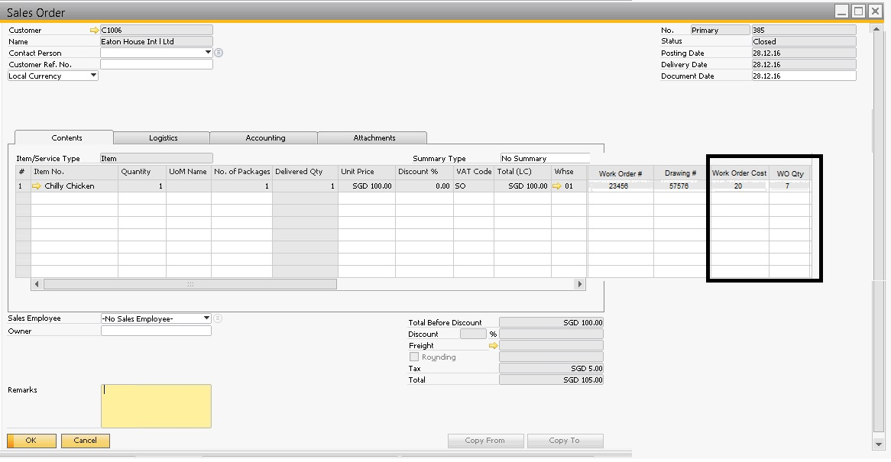

The sales order screen will be updated with the above new fields as shown above. These columns can be added to the sales order form from **Form Settings button. (Ref to screenshot below)**

* **Work Order Cost** – This will be greyed out. User cannot edit this
* **WO Quantity** – This will be greyed out. User cannot edit this
* **WO Hours** – This will be greyed out. User cannot edit this

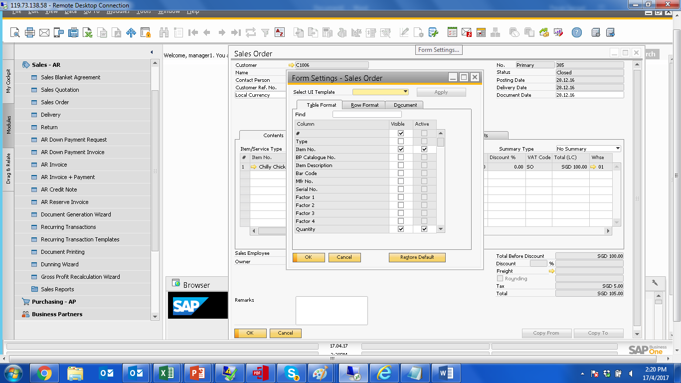

***Please note:***

* ***Incase you have multiple items in the Sales Order but you only have work order details for 1 or 2 then you can use work order details button to update details for only those items for which you have info for. For the remaining ones, you can follow the same procedure once you have work order details for the same.***
* ***Additionally, incase user keys in the incorrect work order quantity and cost then user can edit the same by clicking on WO details button from SO screen.***
* ***Assumption: Incase no Work order (Job No.) or Drawing # is keyed in by user in Sales Order Screen then it will not show up in the new work order details UI.***